Software Requirement Specification
Online Library Management System

Name : Ramakrishnan.G
Ace No : 2072
Date : 3/10/2013
CONTENTS

S.No | Titles | Page No
1 | Introduction
2 | Objective
3 | Problem Statements
4 | Design
4 | 4.1 Class Design
4 | 4.2 Database Design
5 | Modules
 | - Login
 | 5.1.1 Member
 | 5.1.2 Librarian
 | 5.2 Member
 | 5.2.1 Member Registration
 | 5.2.2 Check Authentication
 | 5.2.3 Book Searching
 | 5.2.4 Book Reservation
 | 5.2.5 Reserved Book Cancelation
 | 5.2.6 Book Renewal
 | 5.3 Librarian
 | 5.3.1 View Reserved Book
 | 5.3.2 Book Issue
 | 5.3.3 Add entry in Catalogs
 | 5.3.4 Update Catalogs Entry
6 | Users
 | - Librarian
 | 6.2 Member
7 | Table Structure
- Introduction
LIBRARY MANAGEMENT SYSTEM is a software application to maintain the records related to Book Search, Catalog, Book Issue, Book Returns and all necessary requirements for the Library to manage day to day operations.

- Objective
The main objective of the application is to automate the existing system of manually maintain the records of the Book Issue, Book Return from the student, Catalog and Book Search to be computerized. So the Book Issue, Return, Searching will be faster

- Problem Statements
- Member can create a new account for getting the book in library.
- Member may update their profile.
- Member, Librarian searches the book by the following detail
- Member checks the availability of the Book in the library.
- Member, Librarian wants to know exact location of the Book in Library.
- If book is available then the Member could reserve the book to get.
- Member may also cancel the reserved book.
- Librarian views the reserved Book
- Librarian issues the book to Member who reserve the particular book
- Member gets the book from the Librarian.
- Member renews the book.
- Member returns the book to the Librarian.
- Librarian updates the book status as returned.
- Librarian asks Fine amount if the returned date is overdue without renew.
- Member pays the Fine to Librarian.
- Librarian updates the Fine details and mark as returned.
- Librarian adds the new Book Entry.
- Librarian updates, Deletes the Member Details.

- Design
4.1 Class Design
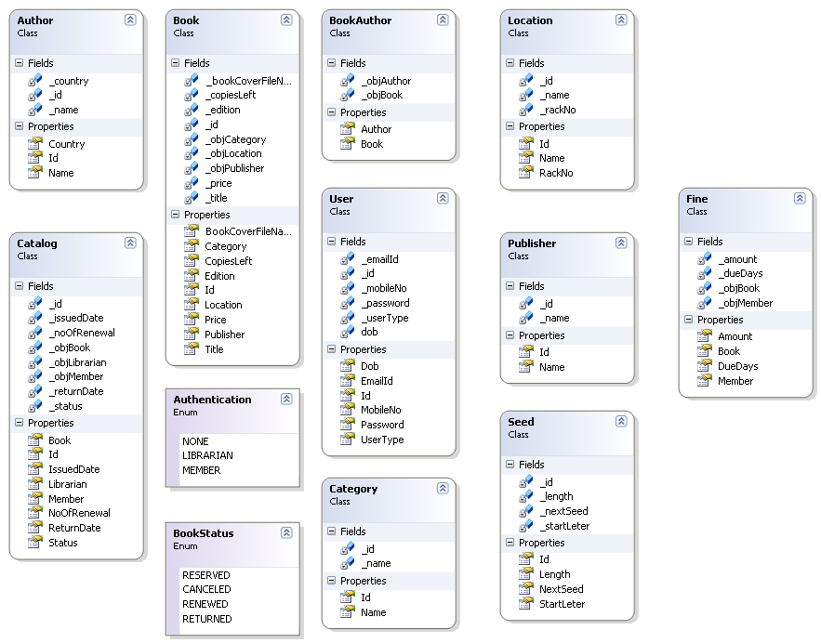

4.2 Database Design
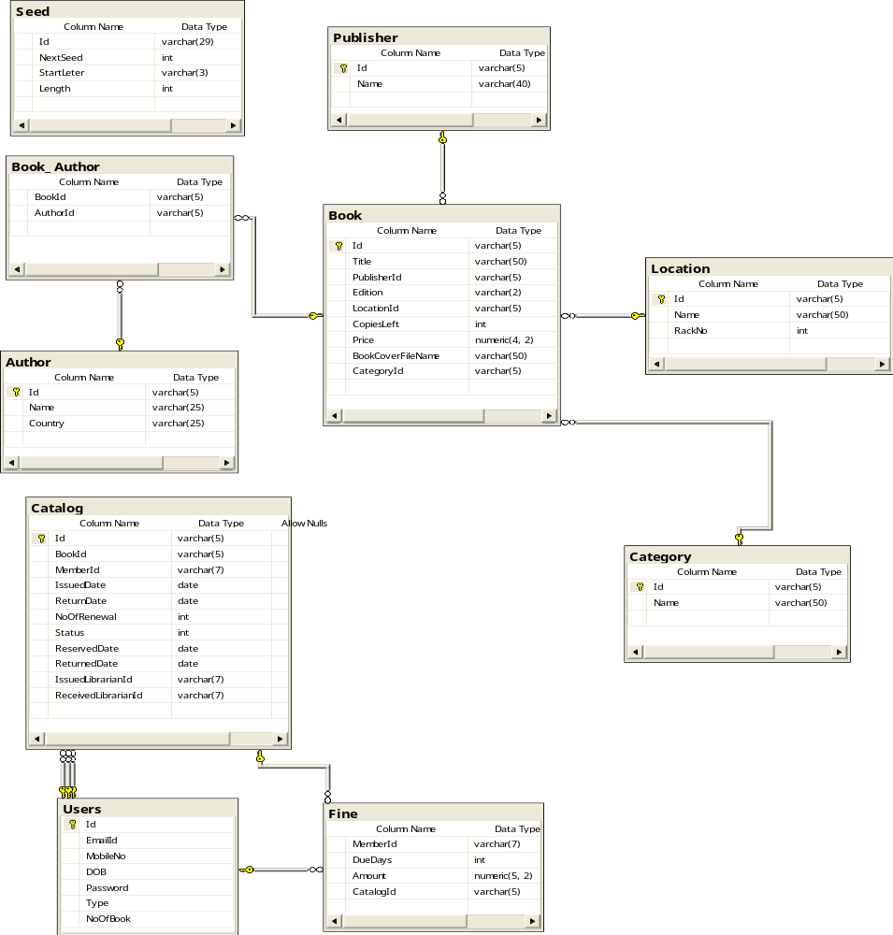

- Modules
  - Login
Log in module is used to authenticate the user by checking the following details.
- User Name
- Password
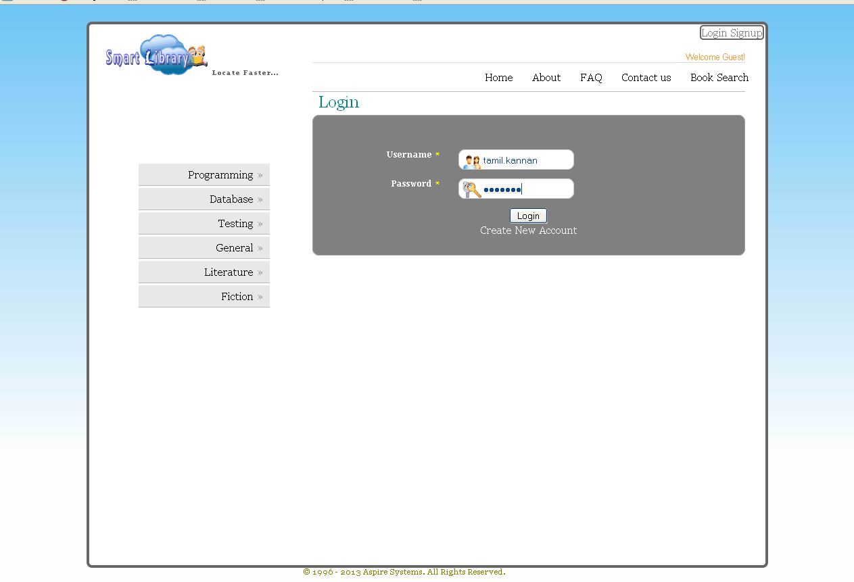
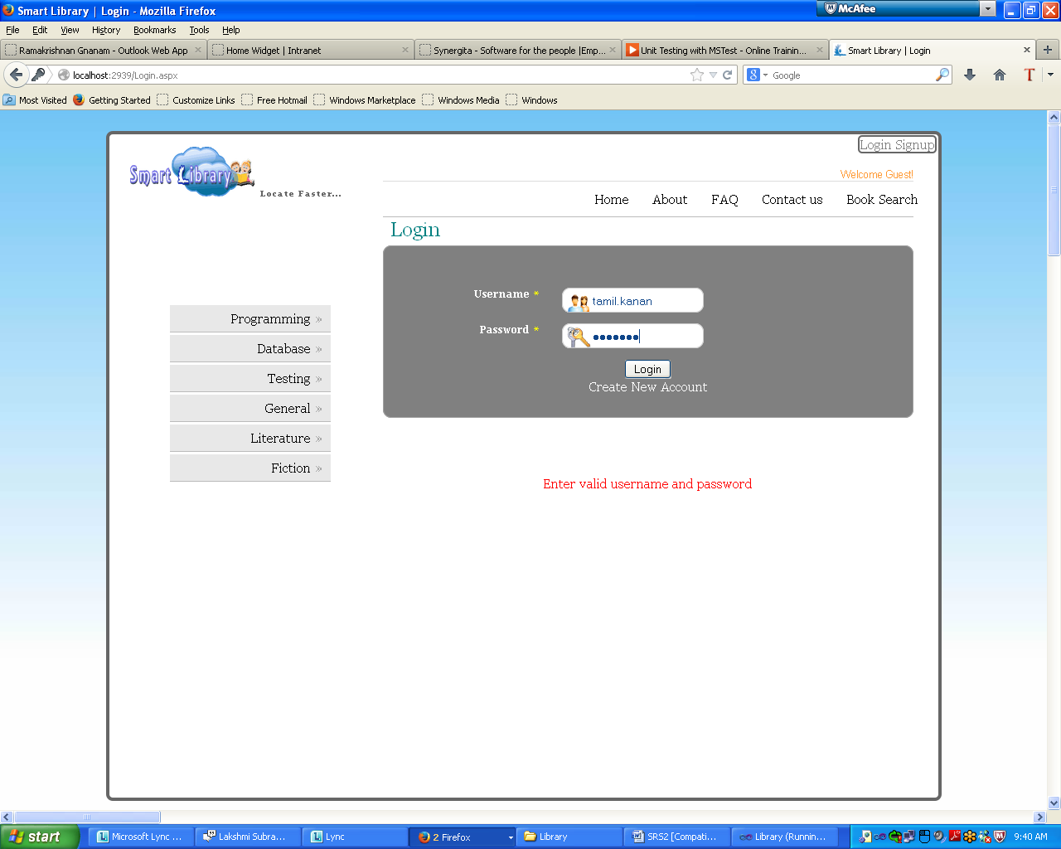

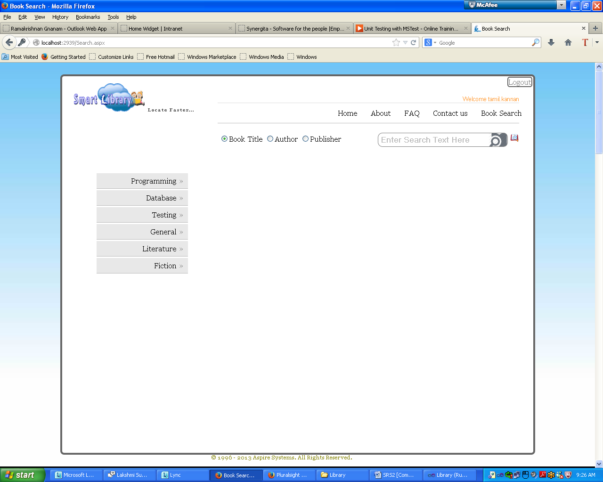

    - Member
Member has to enter their User id and the password for the authentication. The username and password was stored when the process of user registration. After getting authenticated the authorized modules will be shown to the Member.
    - Librarian
Librarian might have the Separate username and password to access the administration modules of the Library Management System.

  - Member
Member has the authentication to access the following modules. If the Member authentication process falls into success then we have these modules.
    - Member Registration
This module allows the user to register as a Member of the Library Management System. The member id will be generated by the system itself.
The following information is needed to register the new member.
- User Name(firastname.lastname)each one has minimum of 4 and Max of 25
- Mobile No.(10 digits)
- DOB
- Password(Length should be between 4 to 8)

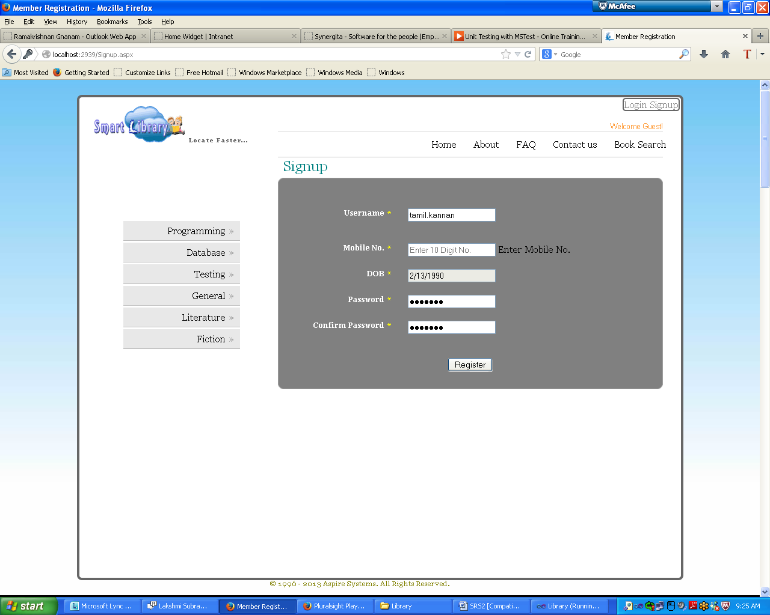
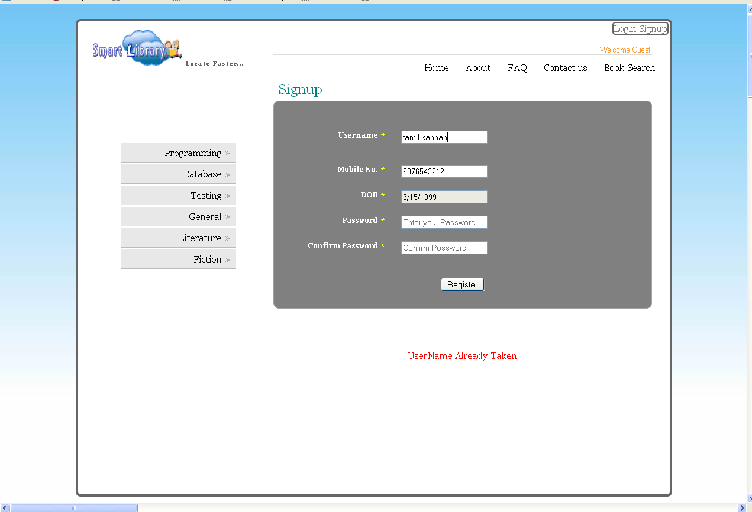

    - Check Authentication
This module is used to check the authentication of the Member and allows to access the System if it is succeeded.
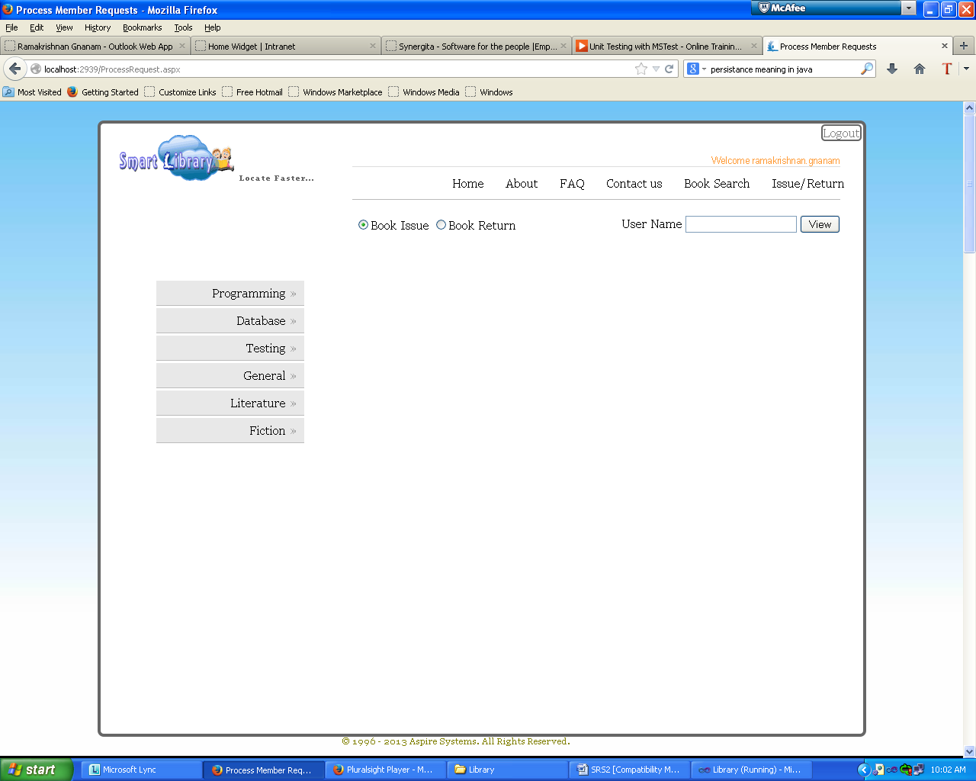
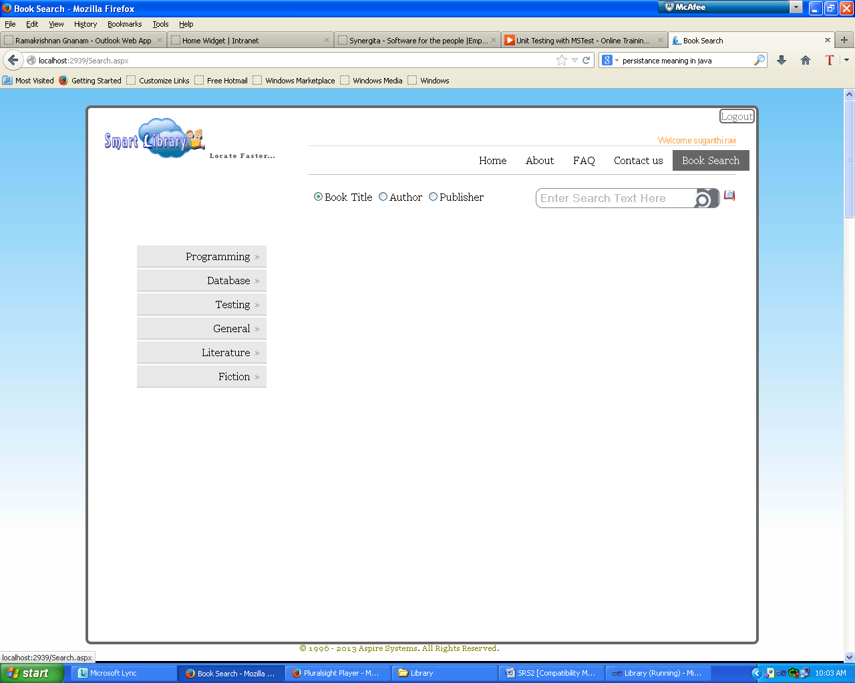
    - Book Searching
This module provides the searching functionality to the member. Member may search the book to reserve on the various categories as the following.
- Author Name.
- Book Title.
- Publisher Name.
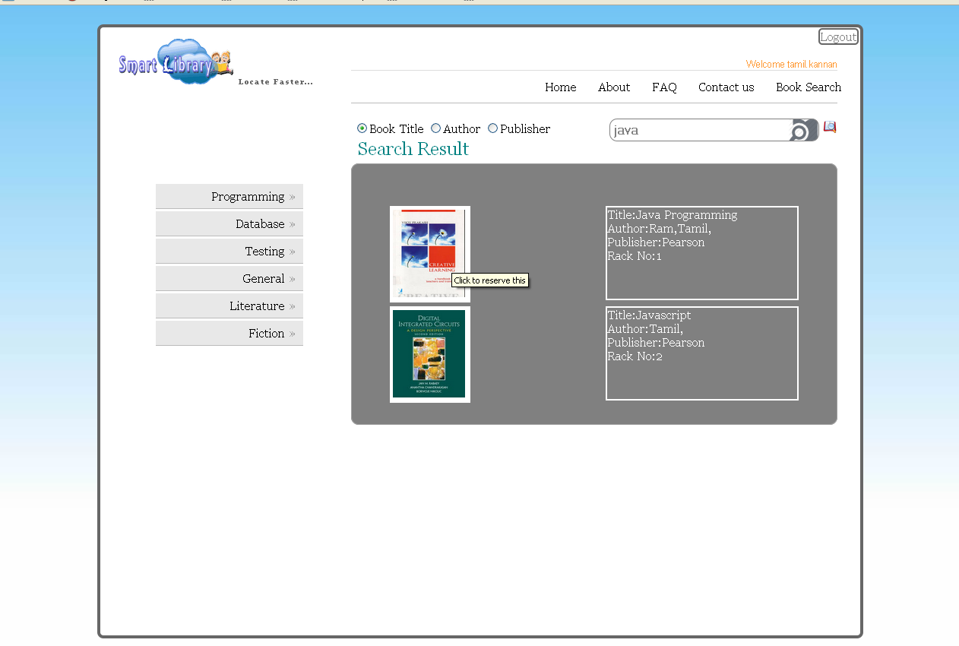
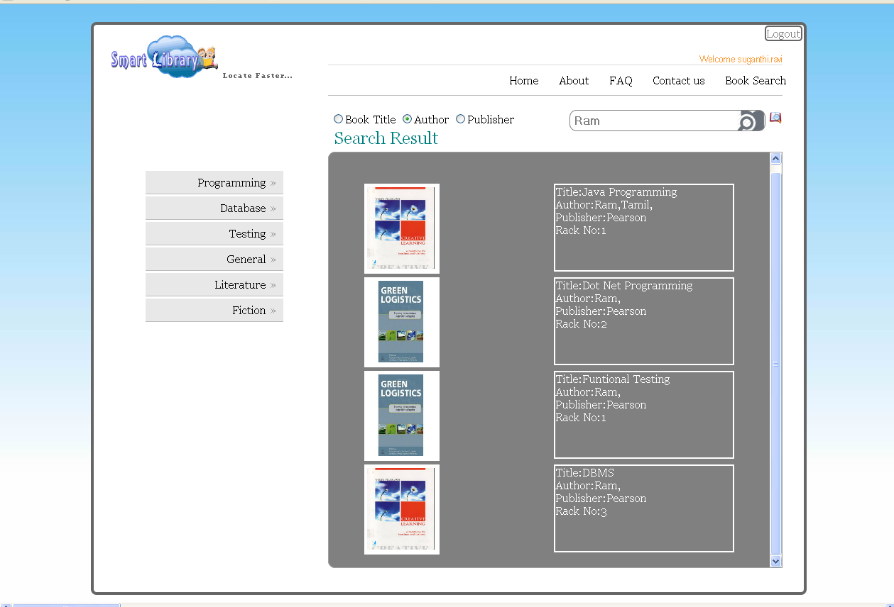
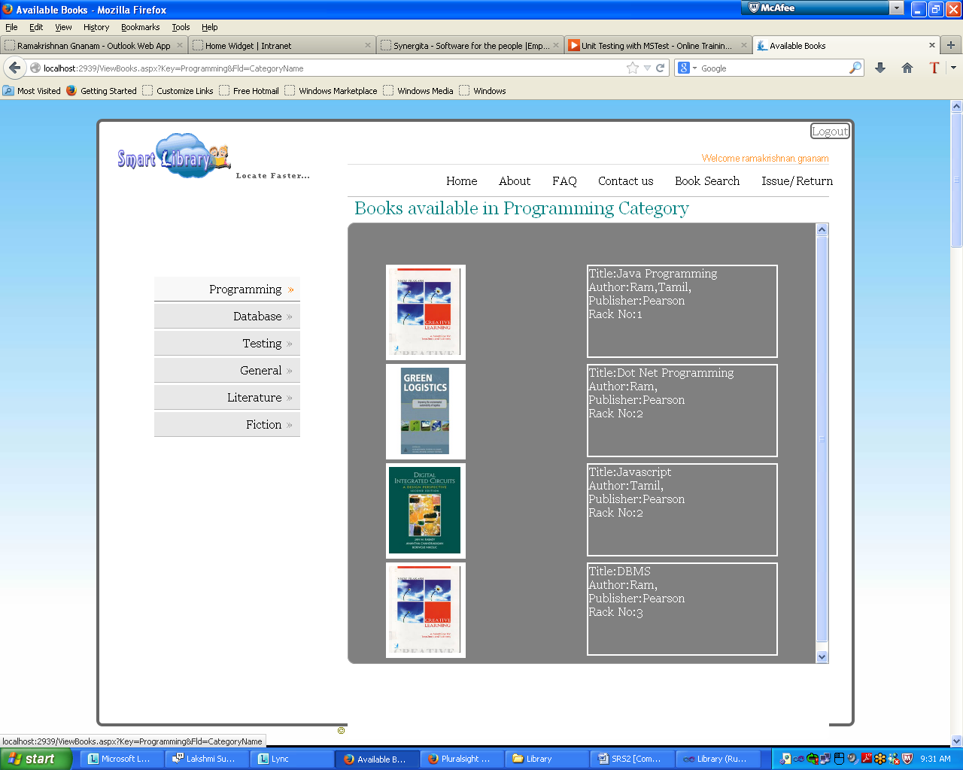
    - Book Reservation
This module allows the user to Reserve the book to get it in later. We can Reserve MAX of Three books per user. When it is reserved the status of the particular book will be set as “Reserved” to avoid the other member to reserve it again.

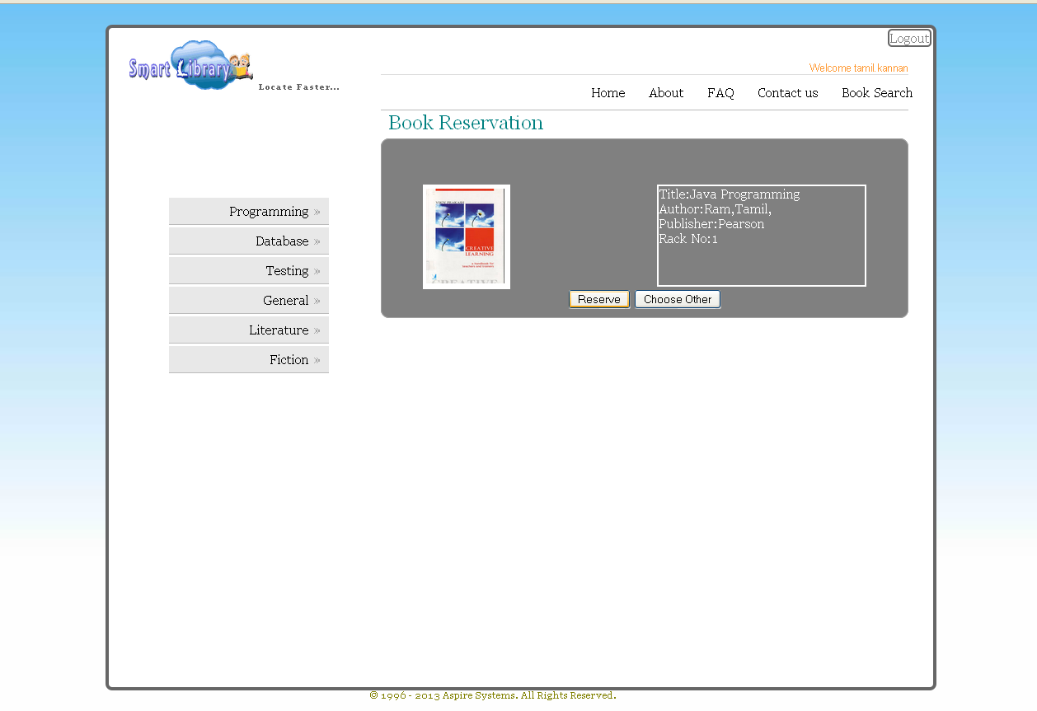
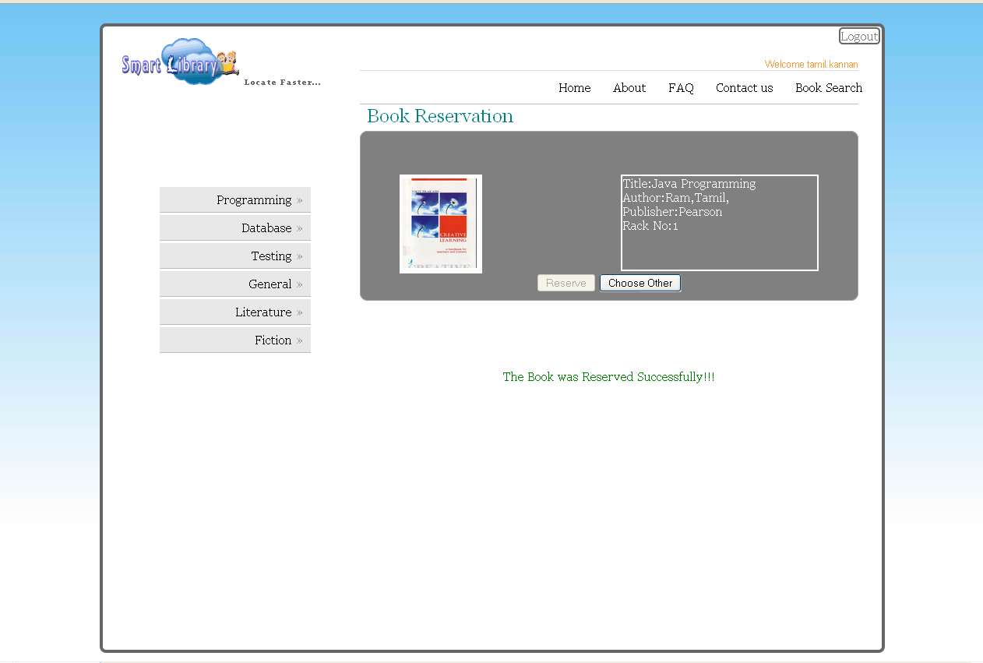
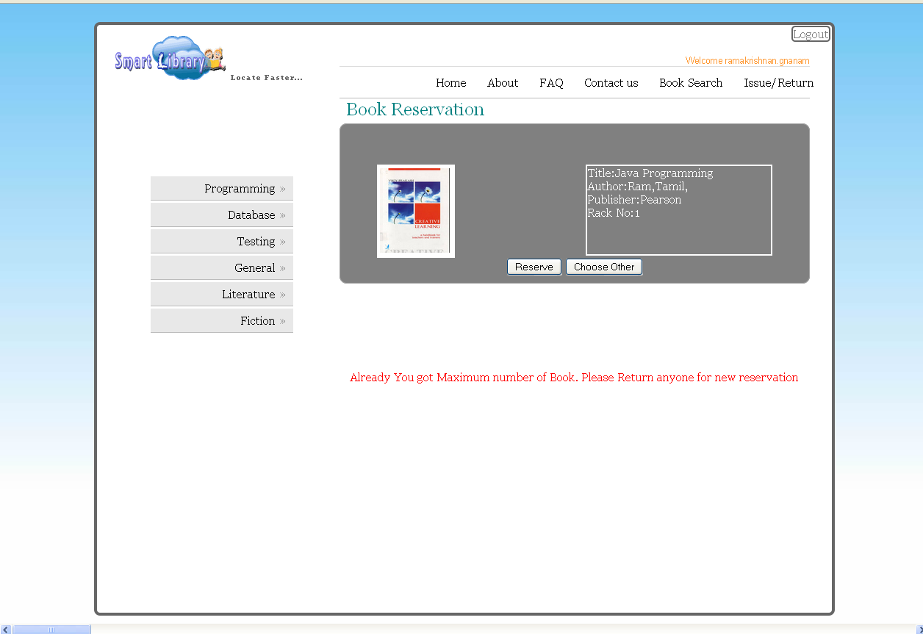
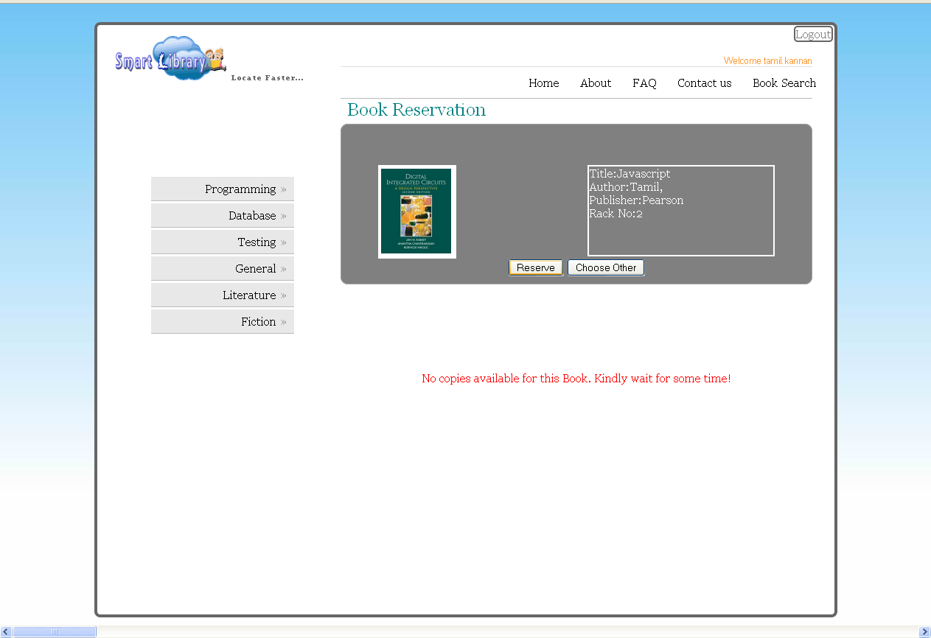

    - Reserved Book Cancelation
The member may or may not cancel the reserved book in later. This module allows the member to cancel the reserved book.
    - Book Renewal
In this module this system provides the functionality to renew the book by the Member to avoid paying fine for overdue date.

  - Librarian
Librarian has the authentication to access the following modules. If the Administration authentication process falls into success then we have these modules.
    - View Reserved/Return Book
In this module Librarian views the reserved book that was reserved by the Member. When the Member came to the library they have to check the book details and Member details for verification.
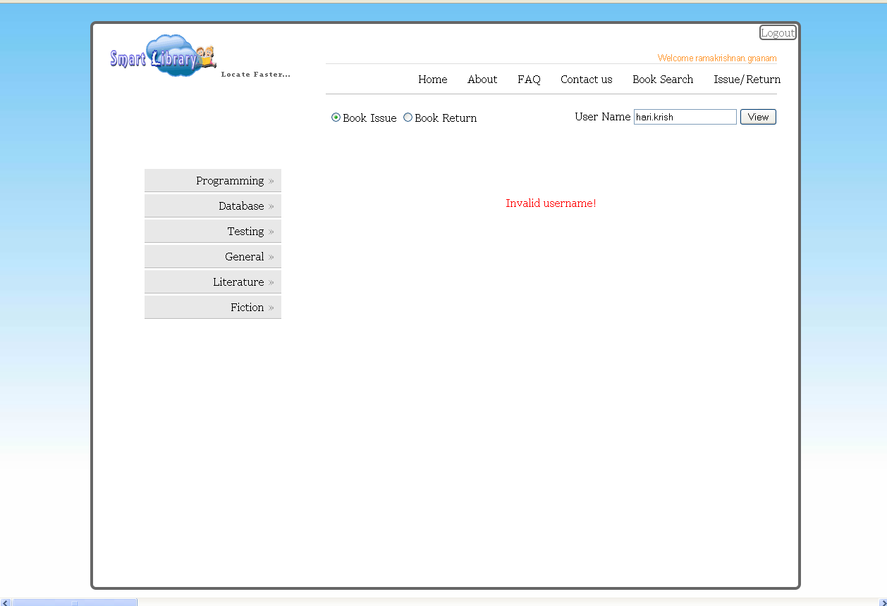
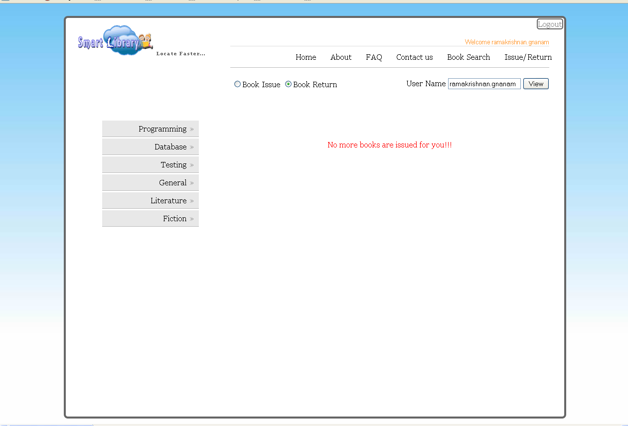
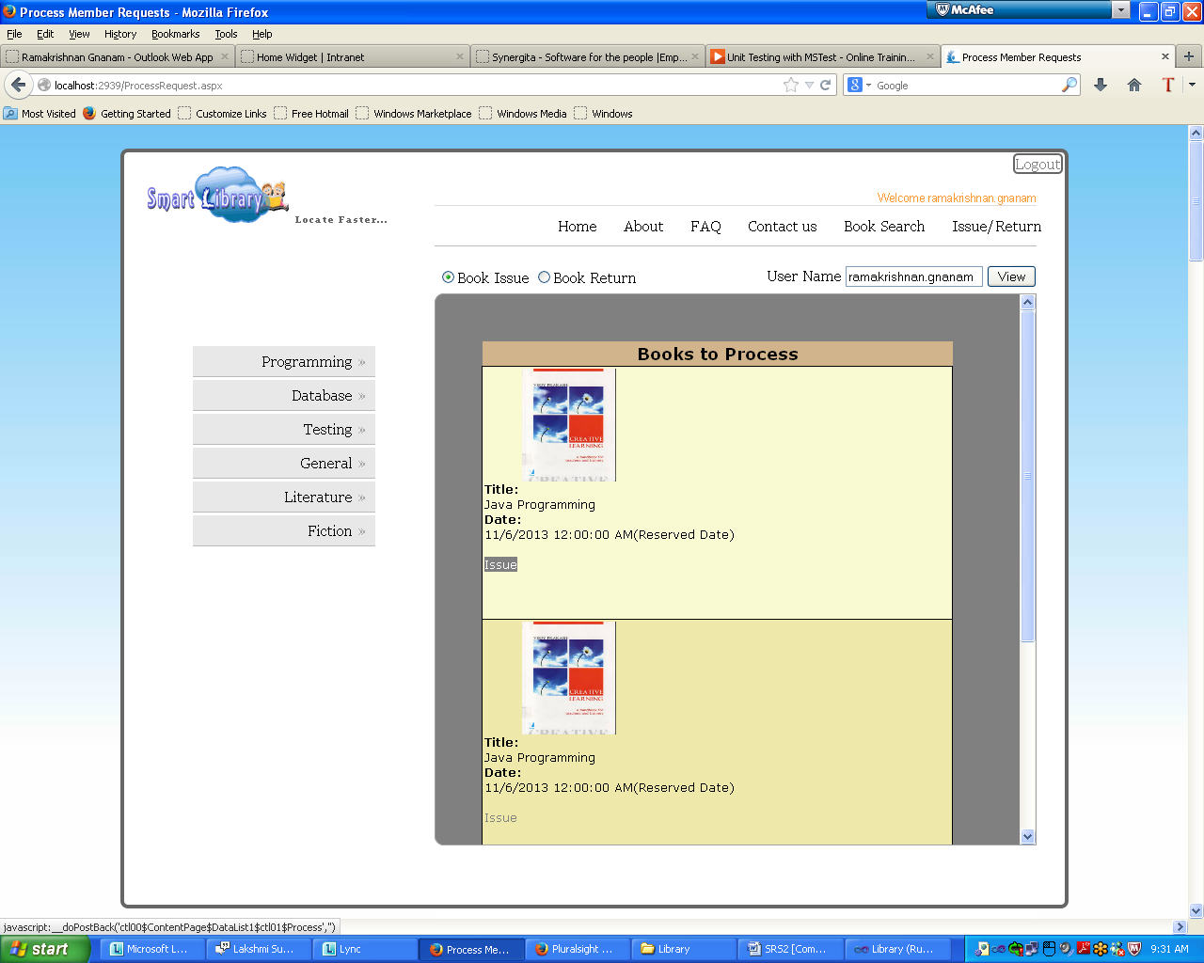

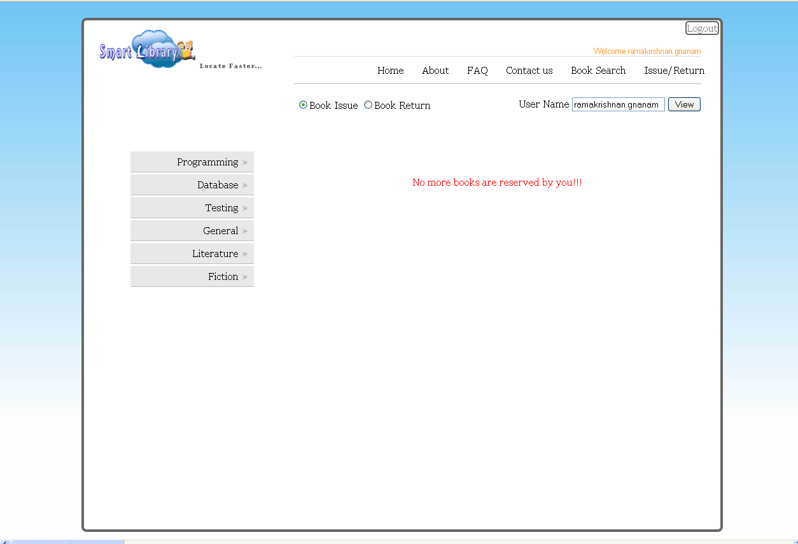

    - Book Issue/Book Receive
If all the details are verified the Librarian issue the book to Member and update entry in the Book/Library catalog as issued.

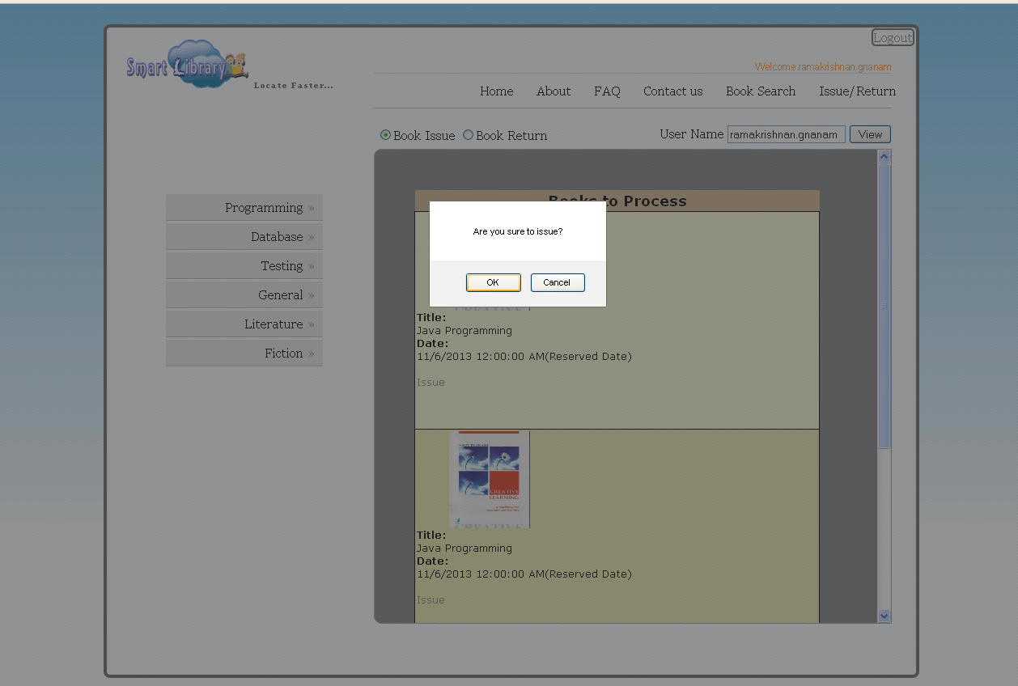

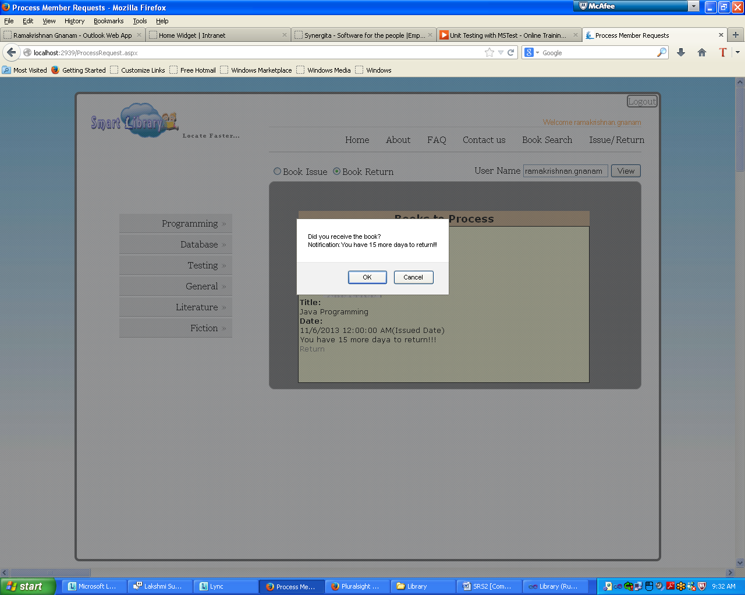
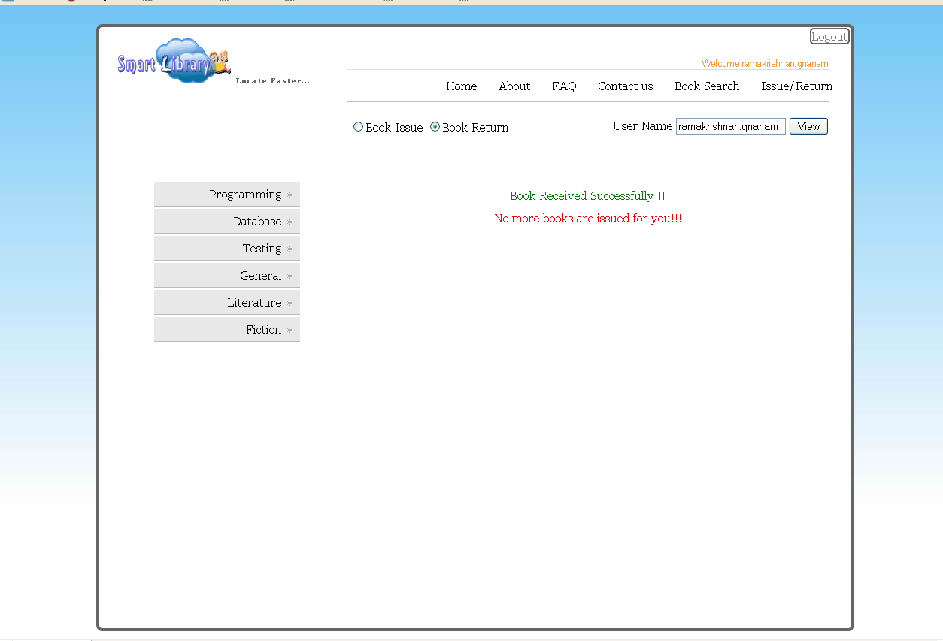

- Users
  - Member
The main user of the library management system is Member of the library. He/She would have the capability to reserve the book, search the book, get the book and view the location of the book.

  - Librarian
Librarian acts as Administrator of the Library Management System. He is a responsible for adding new book, issuing the book, checking the book status and checking the availability of the book.

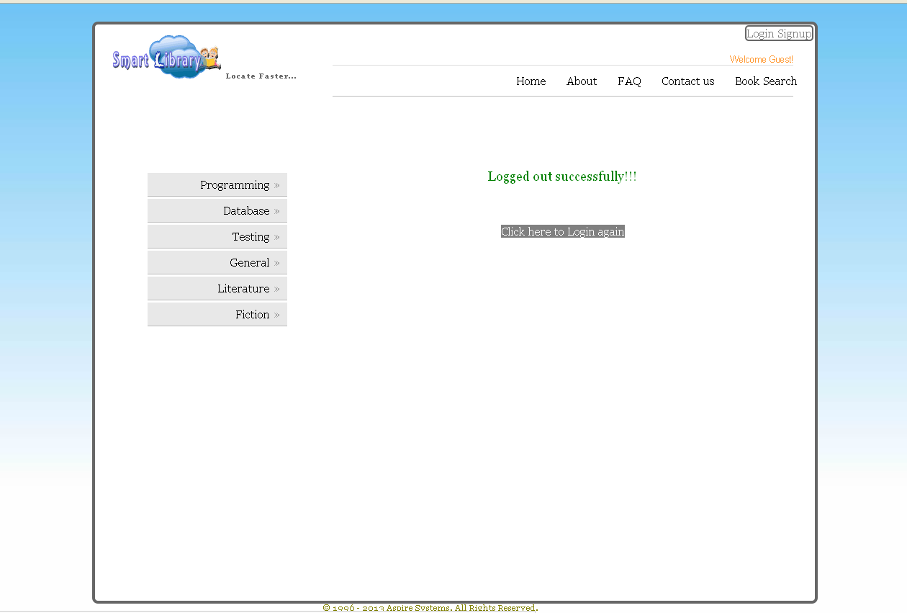

- Table Structure
dbo_User

Field Name | Data Type | Constraints
Id | varchar(7) | Primary Key
EmailId | varchar(50)
MobileNo | varchar(10)
DOB | date
Password | varchar(25)
Type | char(1)

dbo_Location
Field Name | Data Type | Constraints
Id | varchar(5) | Primary Key
Name | varchar(50) | Not Null
RackNo | int | Not Null

dbo_Author
Field Name | Data Type | Constraints
Id | varchar(5) | Primary Key
Name | varchar(25)
Country | varchar(25)

dbo_Publisher
Field Name | Data Type | Constraints
Id | varchar(5) | Primary Key
Name | varchar(40) | Not Null

dbo_Book
Field Name | Data Type | Constraints
Id | varchar(5) | Primary Key
Title | varchar(50)
PublisherId | varchar(5) | Foreign key
Edition | varchar(2)
LocationId | varchar(5) | Foreign key
CopiesLeft | int
Price | numeric(4, 2)
BookCoverFileName | varchar(50)
CategoryId | varchar(5) | Foreign key

dbo_Catalog
Field Name | Data Type | Constraints
Id | varchar(5) | Primary Key
BookId | varchar(5) | Foreign key
MemberId | varchar(7) | Foreign key
IssuerId | varchar(50) | Foreign key
IssuedDate | date
ReturnDate | date
NoOfRenewal | int
Status | char(2)
ReservedDate | Date
ReturnDate | Date
ReturnedDate | Date

dbo_Category
Field Name | Data Type | Constraints
Id | varchar(5) | Primary Key
Name | varchar(50)

dbo_Fine
Field Name | Data Type | Constraints
BookId | varchar(5) | Foreign Key
MemberId | varchar(7) | Foreign Key
DueDays | int
Amount | numeric(3, 2)

